TANK MATE Installation Instructions

IMPORTANT: CONSULT LOCAL CODES FOR INSTALLATION AND USE OF THIS PRODUCT. IN THE ABSENCE OF SUCH LOCAL CODE REQUIREMENTS, THE FOLLOWING ARE MINIMUM RECOMMENDED INSTALLATION AND USE GUIDELINES.
FOR HORIZONTAL TANKS PLEASE CALL 1(877) 482-6562

INCLUDED PARTS NEEDED PARTS (size of matching fittings are at installer’s discretion)

Tank Mate (2)Louvers | (4) Street Elbows; (1) Matching Elbow; (2) Matching 18” nipples  (1) Fill Box; (1) Vent Alarm

STEP 1 – INSTALLATION LOCATION
- Surface must be level and capable of supporting the cover and full oil tank
- A CEMENT SLAB IS SUGGESTED APPROX 77” x 36” CALL toll free 1(877) 4 TANKMATE for information on our CUSTOM SLABS OR FOR A FAX ON CUSTOM SLAB DIMENSIONS

FOR PROPER FIT, TANK SHOULD BE INSTALLED NO FURTHER THAN ¾” FROM THE HOUSE

STEP 2 – PREPARING TANK
- Tank legs should be 6’
- If you have larger tank legs you can use railroad tiles to form a wood frame for the tank mate to sit on.
- You can also cut the existing tank legs to 6”
- We also sell an 8” tank step to raise the tank mate up

STEP 3 – PREPARING TANK MATE
- Drill out fill and vent holes on the sides of the tank mate, with a saw larger then pipe for easy assembly,

see diagram below
STEP 4 – PIPING TANK (Instructions are for installing a 2” Vent, substitute fittings with 1 ¼” when using 1 ¼” vent)
- For Fill Pipe use first tapping on tank, install 2 street elbow and 18” pipe as seen below.
- For Vent Pipe, Install “vent alarm” in last tapping of tank as seen below.
- Continue with vent, install 2 street elbows, then 18” pipe, see diagram below
- Slide the cover over the fill, then the vent to install, call for details,
- Finish off fill & vent piping to installer’s discretion.
- For finishing steps open the accessory kit and install 3” vent and 4” vents as described below

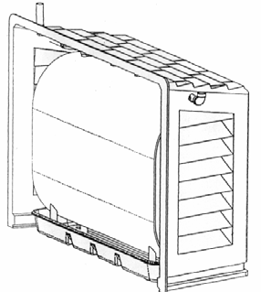
Install site cap where appropriate to view gauge

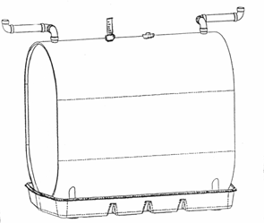
Angle Swing Joints Towards House

Shown With Optional Containment
Install site gauge where appropriate to view bottom of tank.

PLEASE SEE SECOND PAGE FOR AN INSTALLATION CLOSE-UP!

